LAB-09
Areej Hasan 25K-0008 BAI-1A
Question3:
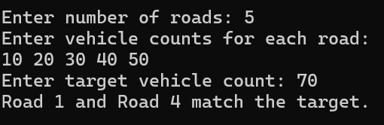
Question 4:
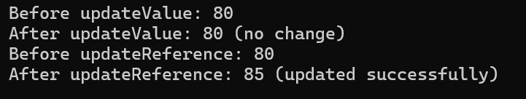
Question5:
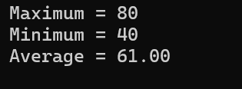
Question6:
